🏥 Hospital Analytics
Excel to MySQL Migration & Power BI Dashboard
MySQL · Python · Power BI · DAX

February 2026

📋 4,000  Patient Records | 🗄️ 8  Database Tables | 🐍 6  Python Reports | 📊 3  Dashboard Pages


Portfolio Project · Data Analysis

1 🔍 Project Snapshot

This project works with a hospital dataset of 4,000 patient records — covering appointments, billing, prescriptions, lab reports, and doctor data. All of it was stored in a single, unstructured Excel workbook with no relational structure, no data validation, and no way to track outstanding payments.

The Problem
Issue | Impact
All data in one flat Excel file | No structure, no relationships between records
No unique identifiers enforced | Duplicate patient and doctor records existed silently
No data validation rules | Gender stored as 'male', 'M', 'm', or blank in same column
No scheduling conflict checks | A doctor could be double-booked without any warning
No access control | Any staff member could view all patient data
Rs. 27.7 Lakhs in unpaid bills | 31% of total revenue with zero visibility or tracking

The Solution
- Normalised MySQL database — 8 tables, 3NF, with constraints, triggers, and stored procedures
- Python automation script — connects to MySQL and exports a formatted 6-sheet Excel report
- Live Power BI dashboard — 3 pages, DirectQuery connection, updated on every refresh

Tech Stack
Tool | Purpose
MySQL 8 | Relational database — schema, migration, triggers, stored procedures
MySQL Workbench | Schema design, data import wizard, SQL execution
Python 3 | Automation script — PyMySQL, pandas, openpyxl
Jupyter Notebook / VS Code | Python development environment
Power BI Desktop | Interactive dashboard with DirectQuery live connection
DAX | Calculated measures and KPI labels for the dashboard

2 🗄️ Database Design & Migration

The flat Excel file was decomposed into 8 normalised tables following Third Normal Form (3NF). Every entity got its own table with a primary key, and relationships are expressed through foreign keys — mirroring how a real hospital system works.

Table Structure
Table | Description | Key Dependency
departments | Hospital department names and IDs | None
doctors | Doctor profiles — name, role, specialization | departments
patients | Patient demographics — name, DOB, gender, phone | None
appointments | Core fact table — links patients, doctors, time, status | patients, doctors
bills | Billing records per appointment | appointments
prescriptions | Medication and dosage per appointment | appointments
labreports | Lab results linked to each appointment | appointments
doctor_credentials | Login credentials with role-based access | doctors
audit_log | Auto-logs every appointment INSERT with timestamp | appointments

Migration Approach
Migration was done in a controlled sequence to respect foreign key dependencies. Both CSV files were first imported into staging tables with all columns as TEXT — this prevented automatic type conversion errors during import.

- Import source CSV into staging table (all TEXT columns)
- Migrate departments — no dependencies
- Migrate doctors — depends on departments
- Migrate patients — no dependencies
- Migrate appointments — depends on patients and doctors
- Migrate prescriptions, bills, and lab reports — all depend on appointments
- Migrate doctor credentials — depends on doctors

Triggers & Stored Procedures
Object | Type | What It Does
CHECK_NEW_APPOINTMENT | Trigger | Blocks double-booking — a doctor cannot have two appointments at the same time
AUDIT_APPOINTMENT_INSERT | Trigger | Logs every new appointment with timestamp and USER() automatically
VIEW_DOCTOR_DATA | Procedure | Role-based access — each doctor only sees their own data
SP_MONTHLYREVENUE | Procedure | Monthly revenue breakdown by department
SP_DOCTOR_PERFORMANCE | Procedure | Per-doctor revenue, paid/unpaid counts, and cancellation totals
SP_UNPAID_BILLS_REPORT | Procedure | Uncollected revenue per department as % of total revenue

3 🐍 Python Automation — MySQL to Excel

After the database was built, a Python script was written to automate the reporting workflow. It connects directly to MySQL, runs six analytical queries using multi-table JOINs, and exports everything as a professionally formatted Excel workbook — one query per sheet.

Libraries Used
Library | Purpose
pymysql | Connects to MySQL database from Python
pandas | Runs SQL queries and loads results into DataFrames
openpyxl | Writes DataFrames to Excel and applies formatting
os | Builds file save path that works on any operating system

Excel Output — 6 Sheets
Sheet | Content
Monthly Trend | Collected vs uncollected revenue across all 13 months
Revenue All Months | Total revenue broken down by department and month
Doctor Performance | Revenue, appointments, paid/unpaid count, cancellations per doctor (2025)
Unpaid Bills | Uncollected amount per department with % of total revenue
Appointment Summary | Count and percentage of Completed / Scheduled / Cancelled appointments
Patient Age Groups | Patient distribution across 6 age brackets

Excel Formatting Applied
- Navy blue header row (#1F4E79) with white bold text
- Alternating light blue row colours for readability
- Thin grey borders on all cells
- Auto-fitted column widths, capped at 40 characters
- Frozen header row — stays visible while scrolling

4 📊 Power BI Dashboard

Power BI Desktop was connected directly to the MySQL hospital_db database using DirectQuery mode. This means the dashboard reads live data from MySQL every time it is refreshed — not from a static import. MySQL Connector/NET was installed separately to enable this connection.

🔗 Connection: DirectQuery (live) — not Import mode
🗂️ Data Model: All relationships auto-detected from MySQL foreign keys
📐 Schema Type: Star schema — appointments table as the central fact table
↔️ Relationships: Many-to-One with Single cross-filter direction (correct for star schema)

Page 1 — Hospital Overview
The first page gives a hospital-wide summary at a glance — the most important numbers a manager needs to see immediately.
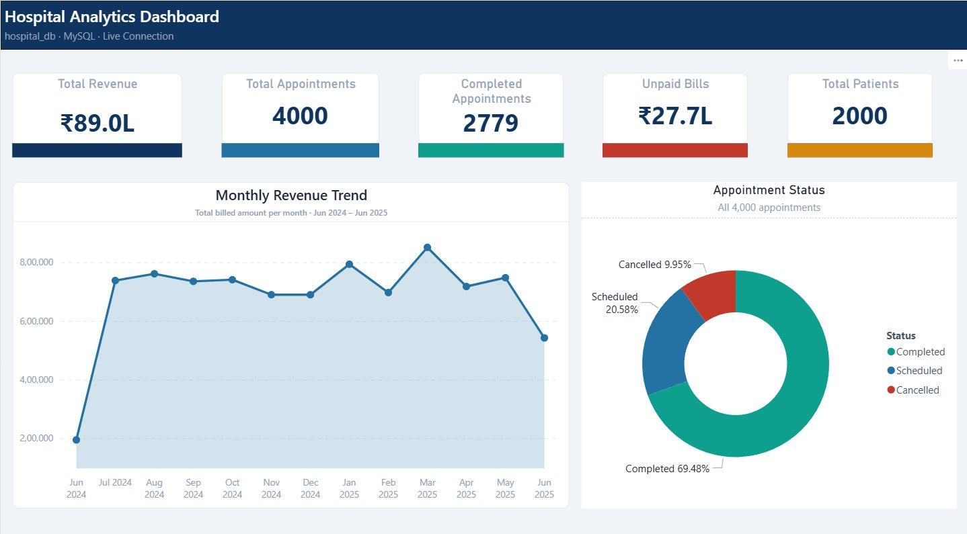
Page 1 — Hospital Overview
KPI | Value
Total Revenue | ₹89.0 Lakhs
Total Appointments | 4,000
Completed Appointments | 2,779 (69.48%)
Unpaid Bills | ₹27.7 Lakhs — immediately visible
Total Patients | 2,000
Data Period | June 2024 – June 2025

Page 2 — Revenue Analysis
Deep financial visibility — makes the unpaid bills problem immediately visible to management, which was completely hidden in the original Excel setup.
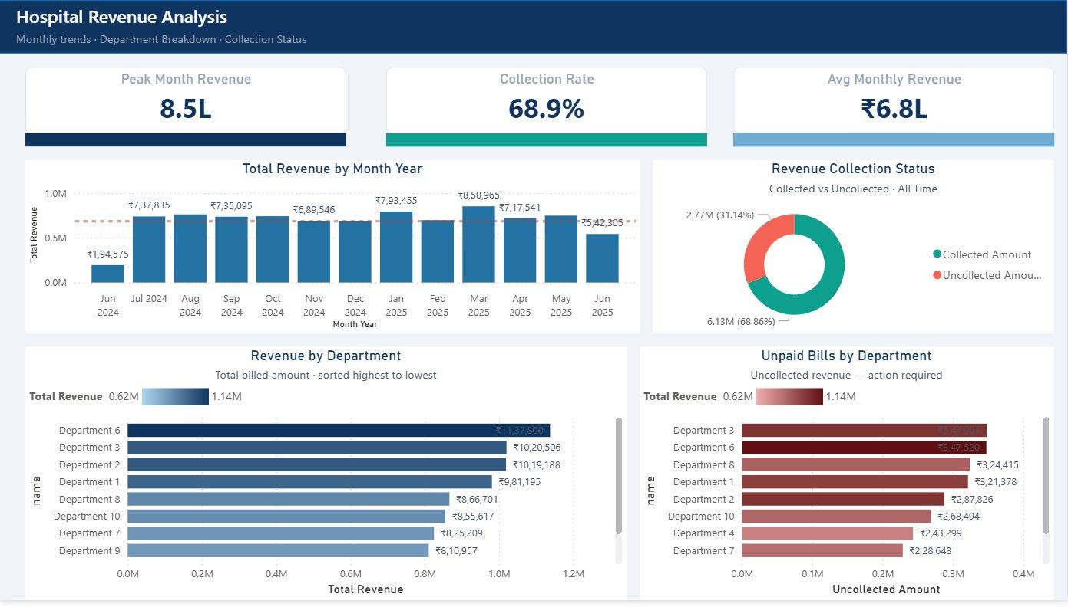
Page 2 — Revenue Analysis

Metric | Value
Peak Month Revenue | ₹8.5L (March 2025)
Collection Rate | 68.9% — 31.1% of revenue is uncollected
Avg Monthly Revenue | ₹6.8L
Highest Unpaid Dept | Department 3 — leads uncollected amount

Page 3 — Doctor Performance
Individual and role-based performance — shows which doctors generate the most revenue and which departments have the most cancellations.
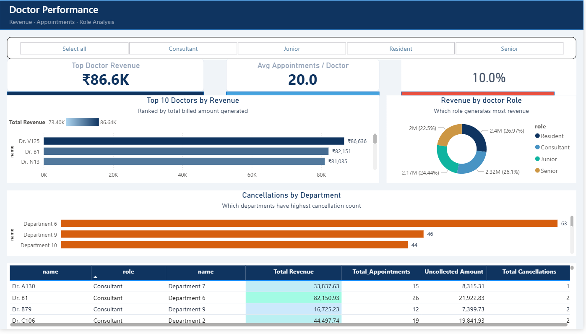
Page 3 — Doctor Performance

Metric | Value
Top Doctor Revenue | ₹86.6K (Dr. V125)
Avg Appointments / Doctor | 20
Highest Revenue Role | Residents — 26.97% of total
Most Cancellations | Department 6 — 63 cancellations

5 💡 Key Business Insights

💰 Rs. 27.7 Lakhs — 31% of total hospital revenue — was sitting uncollected with no
tracking, no visibility, and no way to identify which departments owed the most.
The dashboard makes this immediately visible and actionable.

- Department 3 has the highest uncollected amount, followed by Department 6 — the finance team can now prioritise collection efforts by department

- Nearly 10% of all appointments are cancelled — Department 6 leads with 63 cancellations, suggesting a potential scheduling or capacity issue worth investigating

- Revenue is stable month-to-month at ₹6.8L average — with a notable dip in June 2024 (first month of data) and June 2025 (last month, likely incomplete data)

- Revenue is split nearly evenly across all four doctor roles — Residents and Consultants generate slightly more than Juniors and Seniors

What This Project Demonstrates
Skill | How It Shows
Database Design | Normalized 8-table schema, 3NF, foreign keys, constraints
Data Migration | Controlled sequence, staging tables, data quality filters
SQL | Triggers, stored procedures, multi-table JOINs, CASE logic
Python | MySQL connection, pandas DataFrames, openpyxl formatting
Power BI | DirectQuery, DAX measures, star schema, 3-page dashboard
Problem Solving | 7 bugs identified and fixed, connection error resolved
Documentation | Clean structure, clear explanation of every design decision

6 📐 DAX Measures Reference

All DAX measures used across the three dashboard pages are listed below. This is useful for interview reference — to explain what each measure does and why it was built that way.

Core Numeric Measures
These return numbers and can be used in any visual — cards, charts, tables, and further calculations.

Measure Name | What It Calculates
Total Revenue | SUM of all bill amounts
Collected Amount | SUM of bill amounts where paid = TRUE()
Uncollected Amount | SUM of bill amounts where paid = FALSE()
Collection Rate % | Collected Amount divided by Total Revenue × 100
Total Appointments | COUNT of all appointment records
Completed Appointments | COUNT of appointments where status = Completed
Cancelled Appointments | COUNT of appointments where status = Cancelled
Total Patients | DISTINCTCOUNT of patient IDs
Avg Monthly Revenue | AVERAGEX over months of total revenue per month
Peak Month Revenue | MAXX over months of total revenue per month

Label Measures (KPI Cards Only)
These return text strings formatted with the Rs. symbol and L (Lakhs) suffix. Used only in KPI card visuals — cannot be used in charts or calculations.

Measure Name | Format Example
Total Revenue Label | Rs. 89.0L
Unpaid Bills Label | Rs. 27.7L
Collected Amount Label | Rs. 61.3L
Avg Monthly Revenue Label | Rs. 6.8L
Peak Month Label | Rs. 8.5L

Calculated Columns
Column-level calculations added to tables — unlike measures, they compute a value for each row individually and are stored in the data model.

Column | Table | What It Does
Month Year | bills | Formats bill date as 'Jun 2024' for time-axis charts
Age Group | patients | Bucketes patient age into brackets (0-18, 19-30, etc.)
Revenue Band | doctors | Groups doctors by revenue tier for conditional formatting

